**Member function**

* **Below method to compute the extra hour charges of doctor, aditionalOTcharge will be calculated by multiplying the doctor's visiting Charge with extar hours and a rate percentage given as a parameter.**

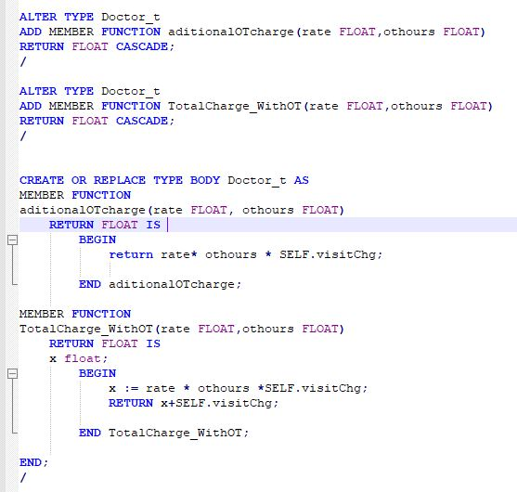

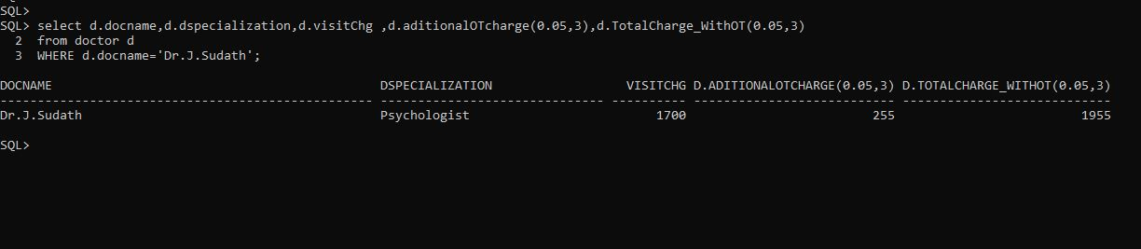

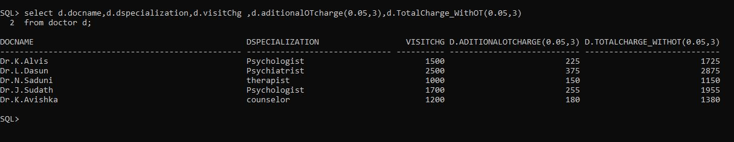

* **this member method to compute the Adolescents payment fee discount with his/her Guardian. The discount is calculated at the 2% of payment fee for each Guardian which dosen't have 'samurdhi'. and this will compute the TAX amount of Adolescents, TAX will be calculated by multiplying the paymentfee with a rate percentage given as a parameter**



